Health care institution "3rd City Dental Polyclinic", Minsk

Project: "CBCT - modern diagnostic technology"
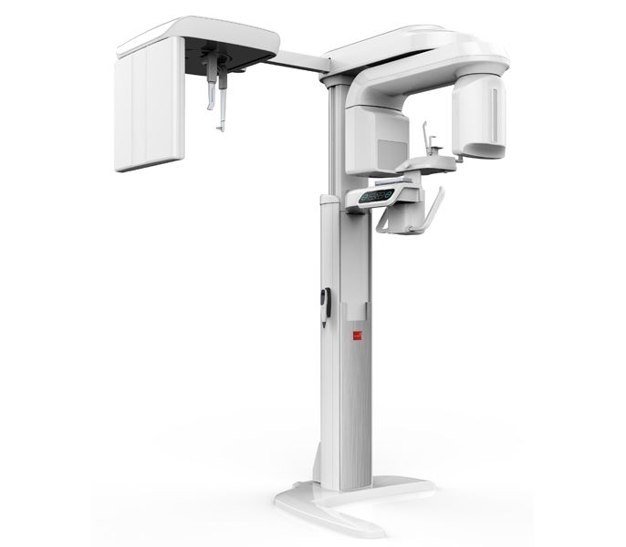
Considering the trend towards an increase in the number of patients suffering from diseases of the maxillofacial region, as well as patients in need of dental implantation, the need for a high-precision diagnostic study using the method of cone beam computed tomography is relevant.
Cone beam computed tomography is a high-tech diagnostic device that provides a high-precision 3D image of the maxillofacial area, which ensures high speed of effective decision-making by the attending physician. The obtained digital information allows the specialist to determine the shape, size, extent and spatial position of pathological processes in the bone structure of the facial skeleton.
Currently, much attention is paid to the problem of providing emergency dental care to the adult population on an outpatient basis. This problem is dealt with by the only health care institution in Minsk “3rd city dental polyclinic”.
Relevance: the need for a highly effective diagnosis of diseases of the dentition and ensuring a high level of dental care, the exclusion of complications during treatment. Cone beam computed tomography is a mandatory diagnostic measure, included in the treatment protocols for patients with diseases of the maxillofacial area and is used in surgical dentistry, prosthetics and implantation, diagnostics during the stages of endodontic treatment, and diagnostics during orthodontic treatment.
In addition to the purely medical aspects of providing medical care in an outpatient setting, the convenient design, dimensions of medical equipment, technical capabilities will ensure high availability and quality of routine and emergency dental care for the population. In addition, the acquisition of a dental computer tomograph will serve to expand the range of services provided in the institution and create new jobs.
With the successful purchase of a cone-beam computed tomography device for the healthcare institution "3rd City Dental Polyclinic" within the framework of the humanitarian project "CBCT - Modern Diagnostic Technology", the device will continue to be carefully handled by specialists from the healthcare institution, including medical specialists and specialists with secondary specialized medical education. In the future, maintenance of the apparatus is planned at the expense of budgetary and extrabudgetary funds of the health care institution "3rd сity dental polyclinic".
Social significance: the project is aimed at modernizing and developing a healthcare facility. Opportunities for the treatment of diseases of the maxillofacial region, drawing up a rational plan for treatment and prosthetics, including the restoration of lost chewing and aesthetic functions, are expanding, and building a trusting contact between the doctor and the patient is ensured.

Name of the project: "CBCT - modern diagnostic technology"
2. Project implementation period: 2023-2024
3. Applicant organization proposing the project: health care institution "3rd city stomatological polyclinic"
4. The purpose of the project: obtaining high-precision results of diagnostic studies of the organs of the maxillofacial area, monitoring the treatment process and proper post-dynamic monitoring using a cone beam computed tomography device manufactured in the Republic of Korea or the People's Republic of China.
5. Tasks planned for implementation within the framework of the project:
- creation of conditions for the most accurate diagnosis of diseases of the maxillofacial region;
- increasing the level of dental care in the 3rd city dental polyclinic;
- exclusion of complications during dental treatment due to high-precision diagnostic examination of the required area;
- conducting dynamic monitoring after the dental treatment provided to assess the quality of treatment at certain time intervals;
- motivating patients to undergo dental treatment, as 3D X-rays allow patients to better understand the results of the diagnosis and make a faster choice in favor of one or another recommended treatment plan;
- medical examination of patients after operations on the bones of the facial skeleton;
- strengthening the material and technical base of the health care institution;
- expanding the range of services at the 3rd City Dental Polyclinic: thanks to 3D technologies, a wider range of services is provided and the stability of the polyclinic is increased.
6. Target group: patients of the health care institution "3rd city dental polyclinic", including disabled people and pensioners who need to be provided with technical means of social rehabilitation.
7. Brief description of the activities within the project:
7.1 Sending letters to humanitarian organizations, embassies, representative offices of manufacturers about the need to purchase medical equipment.
7.2 Conducting training courses and advanced training of medical personnel on working with a cone-beam computed tomography device.
7.3 Conducting seminars for employees of healthcare institutions on the use of the cone-beam computed tomography apparatus.
7.4 Acquisition of equipment and consumables for servicing the device.
7.5 Analysis of the effectiveness of the use of the device cone-beam computed tomography.
7.6 Monitoring the final situation.
8. Total amount of financing (in USD): 70 000
Source of financing | Funding volume  (in US dollars)
Donor funds | 60 000
Co-financing | 10 000
Place of project implementation (region/district, city): healthcare institution "3rd city dental polyclinic", Minsk, st. Kiseleva, 5
9. Contact person:
Muzykantova Victoria Olegovna, chief physician of the 3rd city dental polyclinic,
8 (017) 350 14 13, 8 (044) 738 36 96, e-mail: info@3gsp.by;
Tselishcheva Elena Yuryevna, legal adviser of the 3rd city dental polyclinic,
8 (017) 353 67 56, 8 (029) 373 80 48, e-mail: kadr@3gsp.by

